FSDI 104 – Assignment 3
Name: Charles Taggart
Theme: Object Constructor
GitHub Pages Link: https://github.com/chucktagg83/project104.git

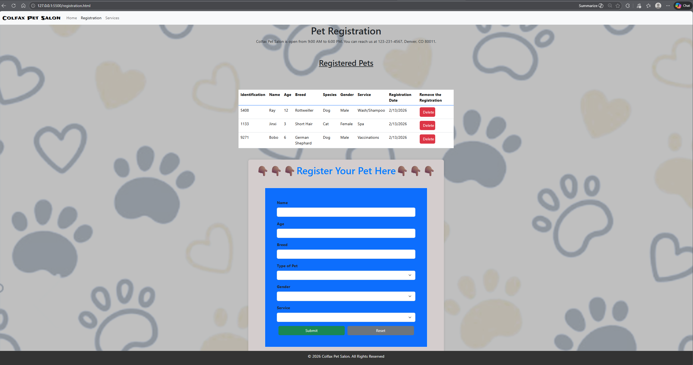
Summary of Edits:
- Created Table for pets added to the registration
- Used bootstrap and google fonts for some of the css
- Event Listener added to connect form submission to the registerProduct function.

